**Engineers for Exploration**

Dillon Hicks

**Get Random Coordinates from Polygon in** 

# Prerequisites:

QGIS 3.0.1

# Setup:

The machine that this documentation ran on was a Windows 10 computer, with no additional software included for GIS.

# 

# 

# 

# 

# 

# 

# 

# 

# 

# Documentation:

The first thing to do is to either open the files from the existing orthomosaic from the georeferenced files or from satellite and street view images from google.

From already existing imagery, add the raster layer using the files

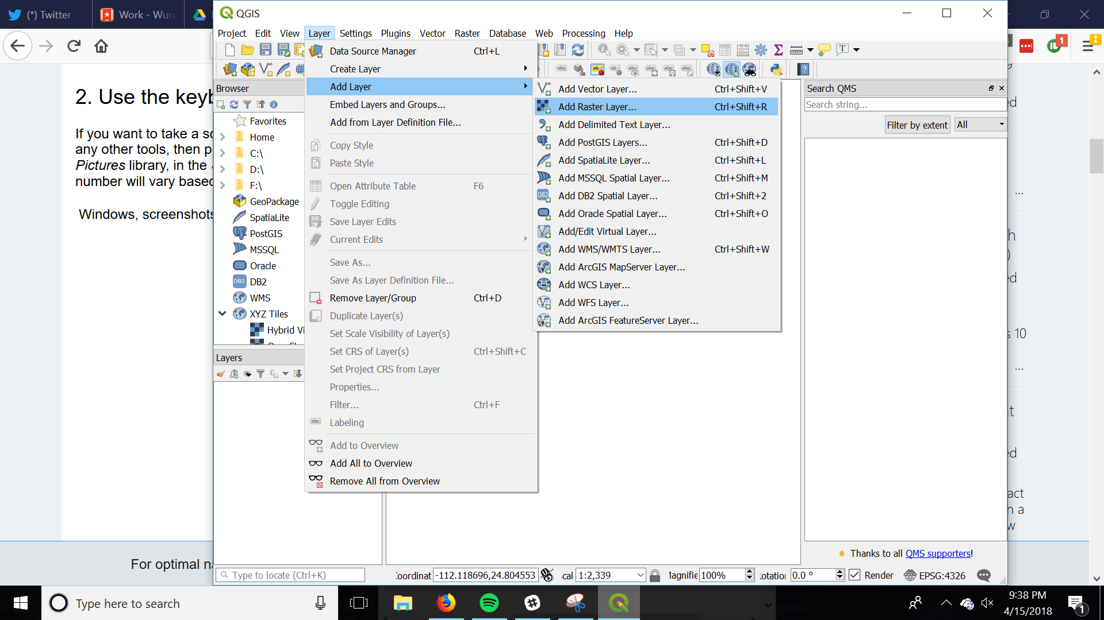

Zoom into your area of interest

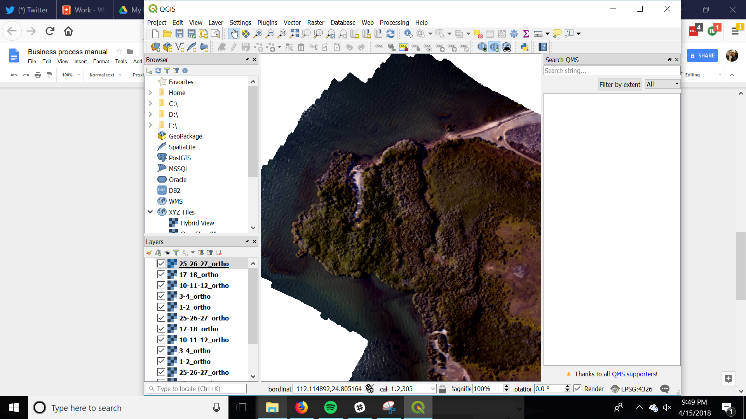

If you want to do it for an area that you don’t have imagery already available, you can do it with the imagery from google maps.

To do this, you need to add the XYZ tile server address of whatever imagery you want to use. Add the server by right clicking on XYZ Tiles under the Browser

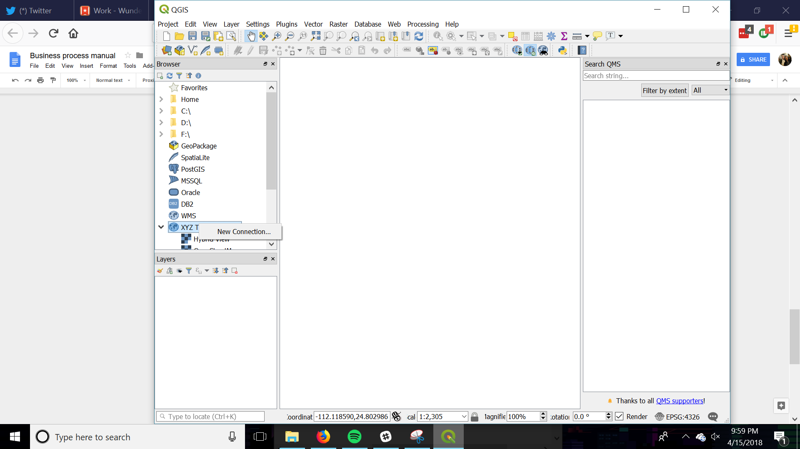

Then type in a name for your imagery and the url of the imagery:

OpenStreetMap:

http://tile.openstreetmap.org/{z}/{x}/{y}.png

Google Hybrid

https://mt1.google.com/vt/lyrs=y&x={x}&y={y}&z={z}

Google Satellite

https://mt1.google.com/vt/lyrs=s&x={x}&y={y}&z={z}

This documentation uses the OpenStreetMap and the google hybrid view 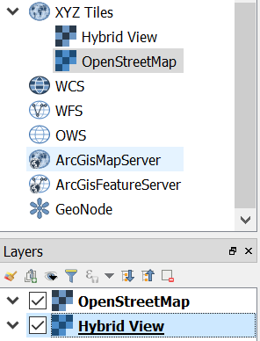

Add each as a layer by double clicking on each XYZ tile

Now we are going to have an overlay of both maps to contain both satellite imagery and trail location data

To add the OpenStreetMap view as an overlay for the hybrid view, right click on your hybrid view layer under the Browser and then click properties

In the transparency tab, you can now set the opacity of the OpenStreetmap view

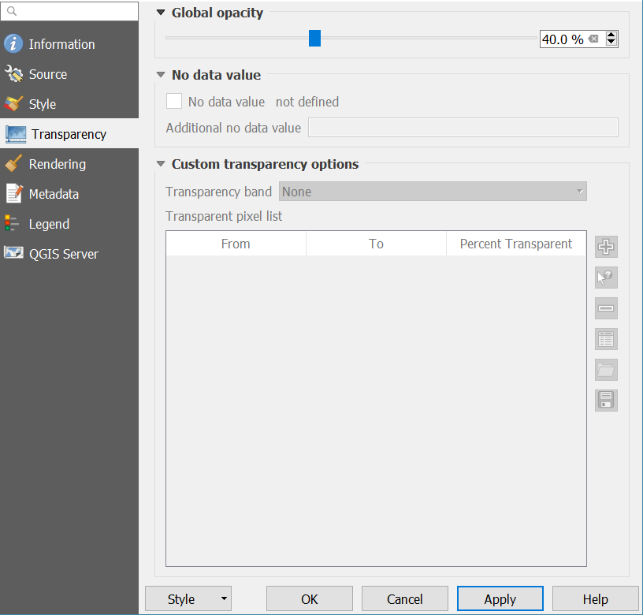

Now you can see the overlay effect of both maps

To make a polygon layer over your map area, click Layer > Create Layer > New Shapefile layer

Add a filename and location, and select a geometry type of polygon. Add a field:

Name with type string and length 80

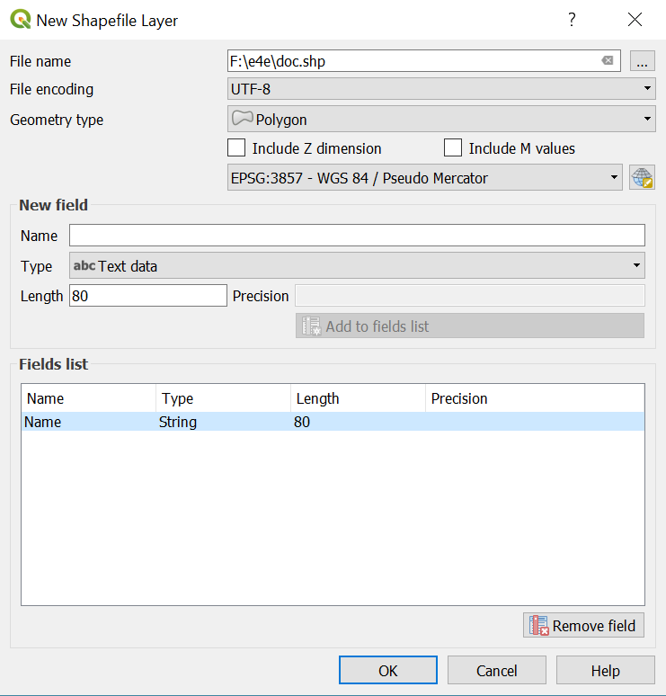

Now that you created a polygon, add the vertices to the polygon to define the area that you want to select random points for.

Click on toggle editing and then add a polygon feature



Click around the map to select the vertices of the polygon of the area that you want. In this example the area of interest is the drone testing area near the eucalyptus grove

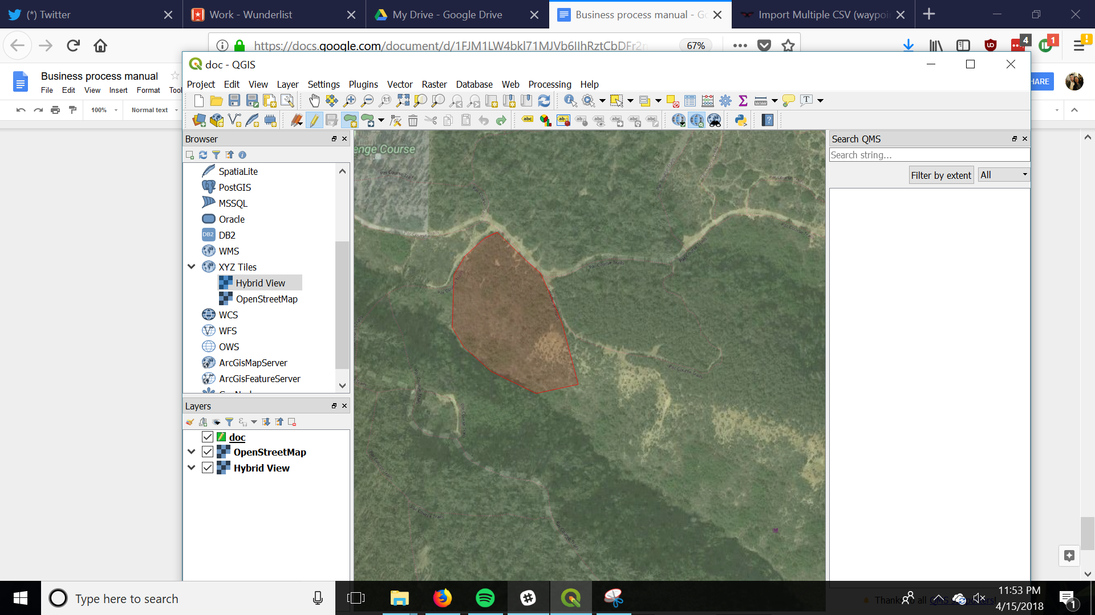

Save it with a name that you choose.

Now we are going to edit the polygon:

RIght click on the polygon in the Layers section and select properties. Go to labels and then under the drop down menu select show labels for this layer. Then in the Label with menu select the variable that you set for the name of this layer.

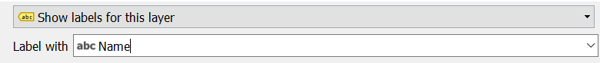

Now you can change the theme of the polygon by going to symbology and selecting the theme.

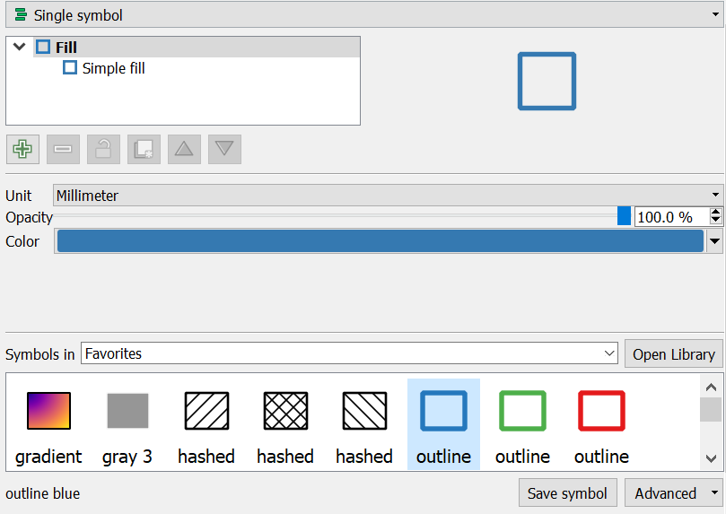

I chose a blue outline so you can see the geography of the selected area.

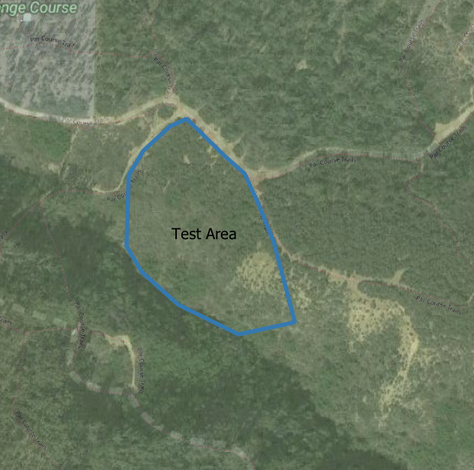

Now we will generate random points within this polygon

Click Vector > Research Tools > Random points in layer bounds

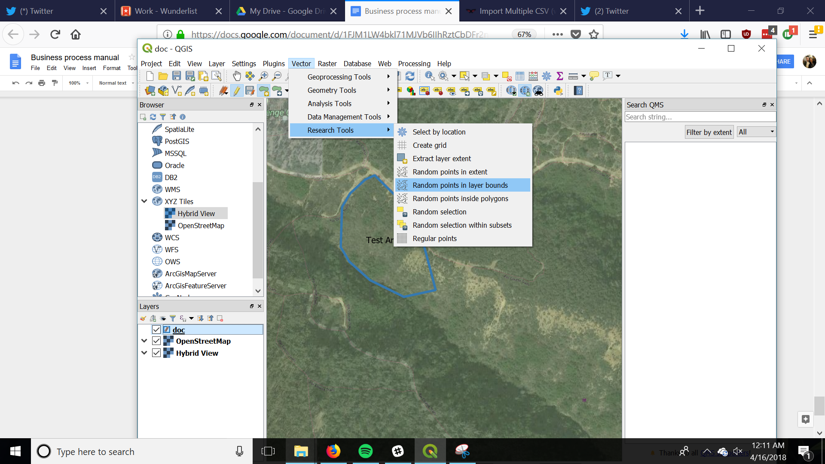

Now select how many points you want and generate the random points

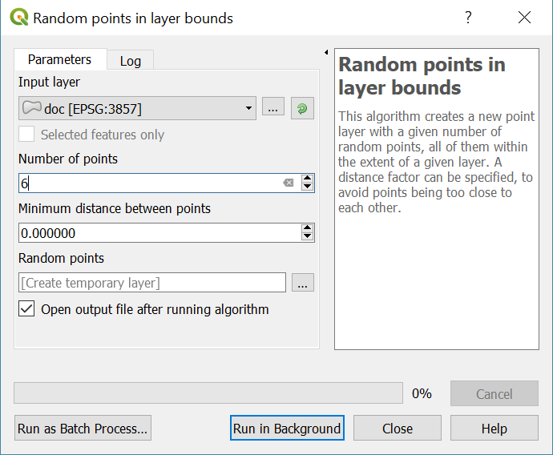

You can choose how many points and the minimum distance between the points. Click Run in Background

The points should now appear on map

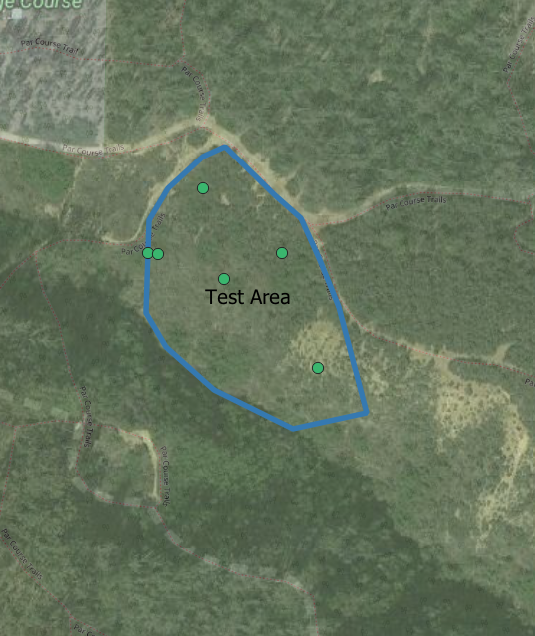

Now to save these random points as a CSV file able to be easily manipulated and used: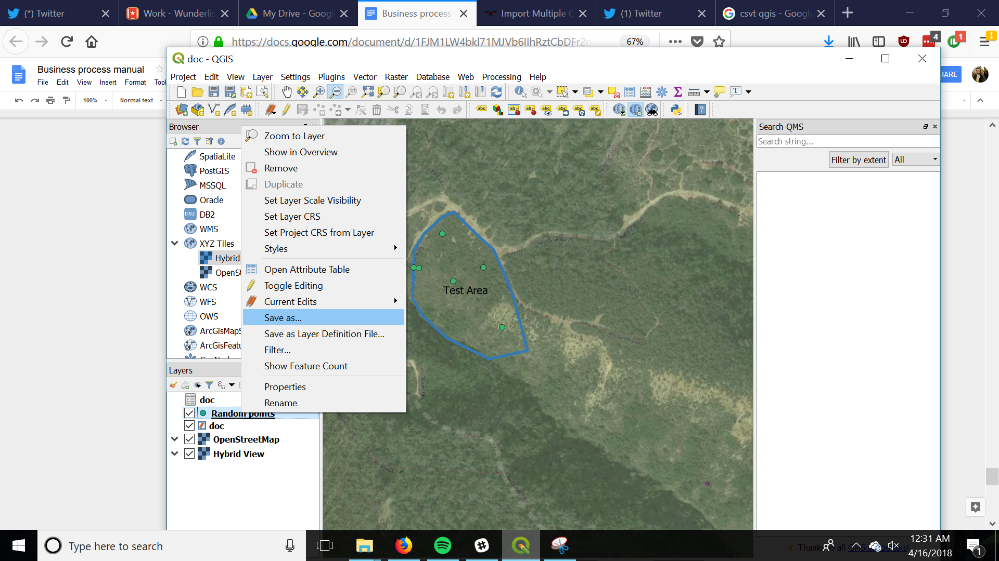

Right click on the points in the layers panel and then click Save as

Now save the Vector layer as a CSV, selecting the geometry AS_XY and removing the id field from the CSV export options.

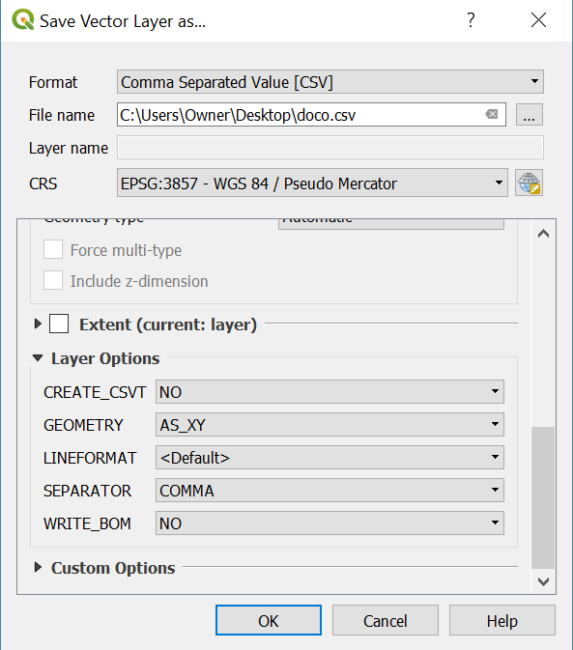

Now you would have your CSV with your random X,Y coordinates to be used with Litchi or DJI GSP

